Lab No | 8
Name | Noor Fatima
Reg No | 23_NTU_CS_1083
Semester | BSCS(6thA)
Subject | Web Development
Submitted to | Sir Abdul Basit
Submission Date | 17_03_2026


Computer Science
National Textile University Faisalabad

Evaluation

Question. No.1
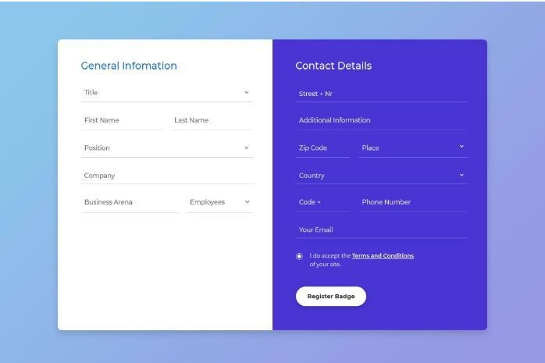
Code:
<!DOCTYPE html>
<html lang="en">
<head>
<meta charset="UTF-8" />
<meta name="viewport" content="width=device-width, initial-scale=1.0"/>
<title>Registration Form</title>
<script src="https://cdn.tailwindcss.com"></script>
<link href="https://fonts.googleapis.com/css2?family=DM+Sans:wght@300;400;500;600&family=DM+Serif+Display&display=swap" rel="stylesheet"/>
<style>
body { font-family: 'DM Sans', sans-serif; }
.input-field {
background: transparent;
border: none;
border-bottom: 1.5px solid rgba(255,255,255,0.35);
outline: none;
width: 100%;
padding: 6px 0;
color: white;
font-size: 0.875rem;
transition: border-color 0.2s;
}
.input-field::placeholder { color: rgba(255,255,255,0.7); font-size: 0.875rem; }
.input-field:focus { border-bottom-color: white; }
.input-field-light {
background: transparent;
border: none;
border-bottom: 1.5px solid rgba(59,130,246,0.3);
outline: none;
width: 100%;
padding: 6px 0;
color: #1e3a5f;
font-size: 0.875rem;
transition: border-color 0.2s;
}
.input-field-light::placeholder { color: #6b93c4; font-size: 0.875rem; }
.input-field-light:focus { border-bottom-color: #3b82f6; }
select.input-field { cursor: pointer; }
select.input-field-light { cursor: pointer; }
select option { background: #1e3a5f; color: white; }
.custom-radio {
appearance: none;
width: 16px;
height: 16px;
border: 2px solid white;
border-radius: 50%;
flex-shrink: 0;
cursor: pointer;
position: relative;
margin-top: 2px;
transition: background 0.2s;
}
.custom-radio:checked {
background: white;
box-shadow: inset 0 0 0 3px #4f46e5;
}
.bg-gradient-card {
background: linear-gradient(135deg, #f0f4ff 0%, #e8eeff 100%);
}
.register-btn {
background: white;
color: #4338ca;
font-weight: 600;
padding: 10px 32px;
border-radius: 999px;
font-size: 0.875rem;
letter-spacing: 0.02em;
transition: transform 0.15s, box-shadow 0.15s;
cursor: pointer;
border: none;
}
.register-btn:hover {
transform: translateY(-1px);
box-shadow: 0 6px 20px rgba(0,0,0,0.2);
}
.register-btn:active { transform: translateY(0); }
.card-shadow {
box-shadow: 0 20px 60px rgba(79, 70, 229, 0.18), 0 4px 16px rgba(0,0,0,0.08);
}
</style>
</head>
<body class="min-h-screen flex items-center justify-center p-6"
style="background: linear-gradient(135deg, #a8c0e8 0%, #c4d4f0 40%, #b8caee 100%);">
<!-- Card -->
<div class="flex rounded-2xl overflow-hidden card-shadow w-full max-w-2xl">
<!-- LEFT: General Information -->
<div class="bg-gradient-card w-1/2 p-8 flex flex-col gap-6">
<h2 class="text-blue-600 font-semibold text-lg tracking-wide" style="font-family:'DM Serif Display', serif;">
General Infomation
</h2>
<!-- Title -->
<div>
<select class="input-field-light">
<option value="" disabled selected>Title</option>
<option>Mr.</option>
<option>Ms.</option>
<option>Dr.</option>
<option>Prof.</option>
</select>
</div>
<!-- First + Last Name -->
<div class="flex gap-4">
<div class="flex-1">
<input type="text" placeholder="First Name" class="input-field-light" />
</div>
<div class="flex-1">
<input type="text" placeholder="Last Name" class="input-field-light" />
</div>
</div>
<!-- Position -->
<div>
<select class="input-field-light">
<option value="" disabled selected>Position</option>
<option>Manager</option>
<option>Developer</option>
<option>Designer</option>
<option>Analyst</option>
<option>Director</option>
</select>
</div>
<!-- Company -->
<div>
<input type="text" placeholder="Company" class="input-field-light" />
</div>
<!-- Business Arena + Employees -->
<div class="flex gap-4">
<div class="flex-1">
<input type="text" placeholder="Business Arena" class="input-field-light" />
</div>
<div class="flex-1">
<select class="input-field-light">
<option value="" disabled selected>Employees</option>
<option>1–10</option>
<option>11–50</option>
<option>51–200</option>
<option>200+</option>
</select>
</div>
</div>
</div>
<!-- RIGHT: Contact Details -->
<div class="w-1/2 p-8 flex flex-col gap-5"
style="background: linear-gradient(160deg, #5b5bd6 0%, #4338ca 60%, #3730a3 100%);">
<h2 class="text-white font-semibold text-lg tracking-wide" style="font-family:'DM Serif Display', serif;">
Contact Details
</h2>
<!-- Street + Nr -->
<div>
<input type="text" placeholder="Street + Nr" class="input-field" />
</div>
<!-- Additional Info -->
<div>
<input type="text" placeholder="Additional Information" class="input-field" />
</div>
<!-- Zip Code + Place -->
<div class="flex gap-4">
<div class="flex-1">
<input type="text" placeholder="Zip Code" class="input-field" />
</div>
<div class="flex-1">
<select class="input-field">
<option value="" disabled selected>Place</option>
<option>City A</option>
<option>City B</option>
<option>City C</option>
</select>
</div>
</div>
<!-- Country -->
<div>
<select class="input-field">
<option value="" disabled selected>Country</option>
<option>Germany</option>
<option>USA</option>
<option>UK</option>
<option>France</option>
<option>Pakistan</option>
</select>
</div>
<!-- Code + Phone -->
<div class="flex gap-4">
<div style="width:30%">
<input type="text" placeholder="Code +" class="input-field" />
</div>
<div class="flex-1">
<input type="tel" placeholder="Phone Number" class="input-field" />
</div>
</div>
<!-- Email -->
<div>
<input type="email" placeholder="Your Email" class="input-field" />
</div>
<!-- Terms -->
<div class="flex items-start gap-3 mt-1">
<input type="radio" class="custom-radio" id="terms" name="terms" />
<label for="terms" class="text-white text-xs leading-relaxed cursor-pointer">
I do accept the
<a href="#" class="underline font-semibold hover:opacity-80 transition-opacity">Terms and Conditions</a>
of your site.
</label>
</div>
<!-- Button -->
<div class="mt-1">
<button class="register-btn">Register Badge</button>
</div>
</div>
</div>
</body>
</html>
Output:
